Model | AR4215
Species |  |  | SCARA
Number of axes |  |  | 4
Arm length |  |  | 400mm
Axis Specification | X Axis | Arm Length | 200mm
Axis Specification | X Axis | Rotation Range | ±127°
Axis Specification | Y Axis | Arm Length | 200mm
Axis Specification | Y Axis | Rotation Range | ±142°
Axis Specification | Z Axis | Route | 150mm
Axis Specification | R Axis | Rotation Range | ±360°
Highest Speed | X Axis |  | 600°/s
Highest Speed | Y Axis |  | 600°/s
Highest Speed | X,Y Axis Synthesis |  | 6.3m/s
Highest Speed | Z Axis |  | 1.3m/s
Highest Speed | R Axis |  | 1667°/s
Standard Cycle Time |  |  | 0.39s
Repeat  Positioning  Accuracy |  | X,Y Axis | ±0.01mm
 |  | Z Axis | ±0.01mm
 |  | R Axis | ±0.005°
Rated / Max Load |  |  | 2KG/5KG
R Axis Allow Load Moment of Inertia(Rated/Max) |  |  | 0.005 KG/㎡
 |  |  | 0.035 KG/㎡
User Signal Line |  |  | 0.2²×16Lines,  8 Output,6 Input
Users Pipe |  |  | φ6×2 Root
Limit Protection |  |  | 1.Software Limit  2.Mechanical Limit(X,Y,Z Axis)
Weight |  |  | 13.3KG

AR4215机器人运动空间，外形及安装尺寸（单位：mm）：
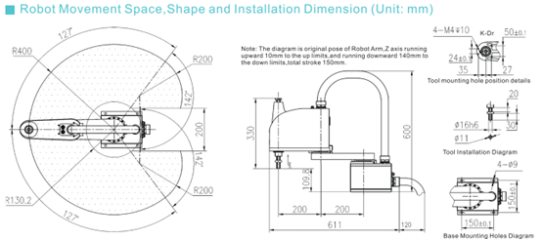
这个部分模糊，请提供清晰图片 (目前没有高清的)

特征与功能：
- 标准循环时间为0.39S
- 臂长400mm
- 额定/最大负载：2/5KG
- 适配控制系统QC400A
5．操作简单，高性能配置，适合宽阔场所的长臂长（这是什么意思？）臂长足够长能够适应宽阔场所。

